*MS-SQL – MySQL Cheat Sheet*

# Contents

Contents 1

MSSQL v MySQL – A note 3

1. Basic Query Settings 3

Select – N.B. Order of statements… 3

SELECT … FROM … WHERE … GROUP … HAVING … ORDER BY 3

WildCards Alias / As … making a temporary column 3

Distinct … showing only one value of each group 3

Where … filtering criteria (equal, not equal, =, <>) 3

Order By … Sorting 4

Like … Searching for a word like … use of WildCards 4

BETWEEN … Values between a range 4

AND / OR 4

Calculated Fields 4

Aggregate Functions 4

Use of null 5

2. Updating, Transactions and Deleting 5

Updating using the Where clause to find record (UPDATE … SET … WHERE) 5

Transactions … Begin, Commit, Rollback 5

Delete 6

3. Aggregates and Subqueries 6

Aggregates – Grouping & Having 6

Group by … Allows for grouping of Aggregate functions 6

HAVING … Filtering Grouped data 7

Grouping / Having Rules 7

Subquery 7

Joins 8

LEFT JOIN … Show only the results from first table in this case 8

WHERE Suppliers.Balance > 100 8

RIGHT Join … Show results from the second table in this case 8

4. Links 9

Difference between ORDER by and GROUP 9

30 Important Sample Queries 9

Sample Exercises 9

Generating a ERD from existing MySQL DB 9

## MSSQL v MySQL – A note

While there are differences in some of the smaller items, for the most part, both languages are very similar. So, these notes could be used for either

# Basic Query Settings

## Select – N.B. Order of statements…

### SELECT … FROM … WHERE … GROUP … HAVING … ORDER BY

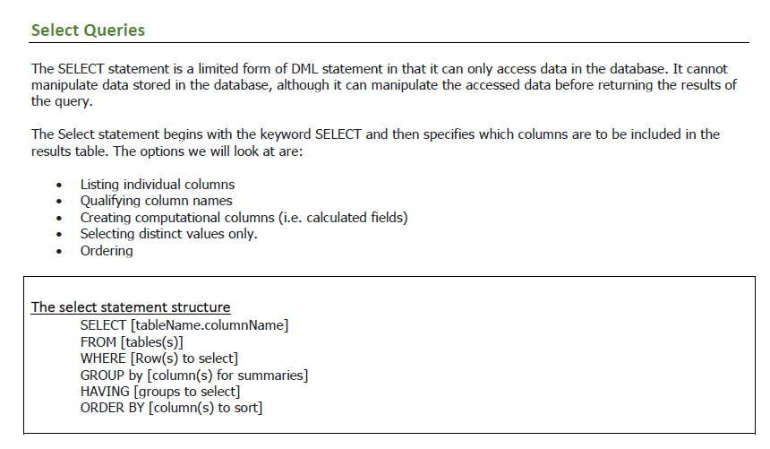

## WildCards Alias / As … making a temporary column

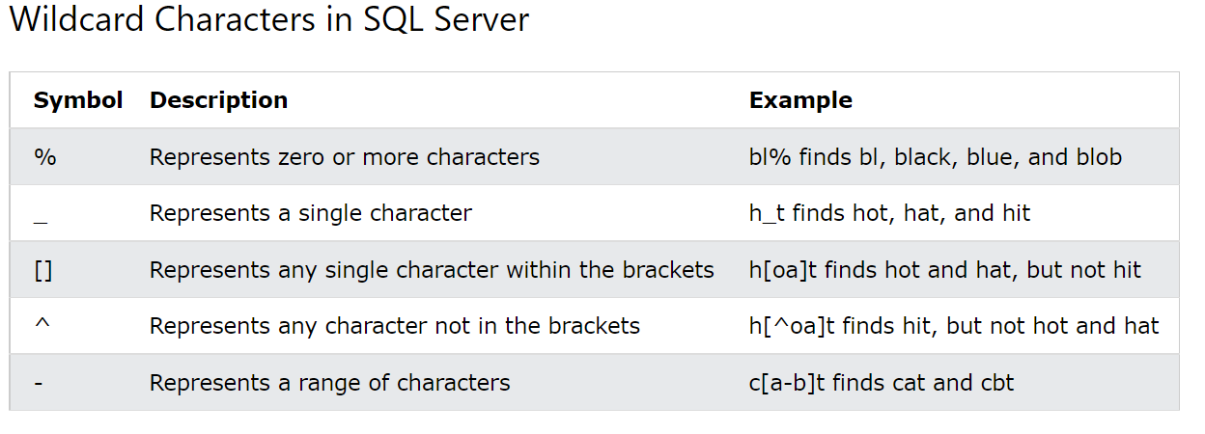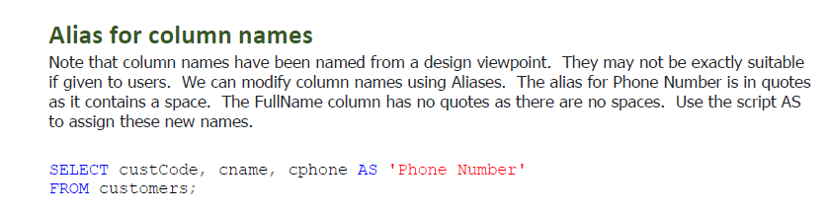

## Distinct … showing only one value of each group

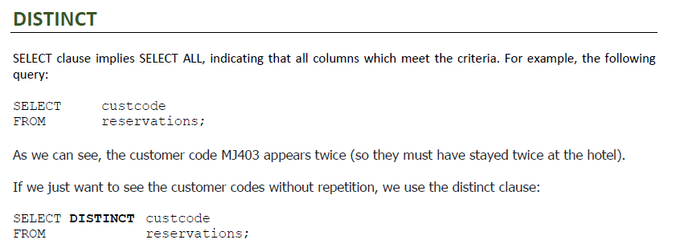

## Where … filtering criteria (equal, not equal, =, <>)

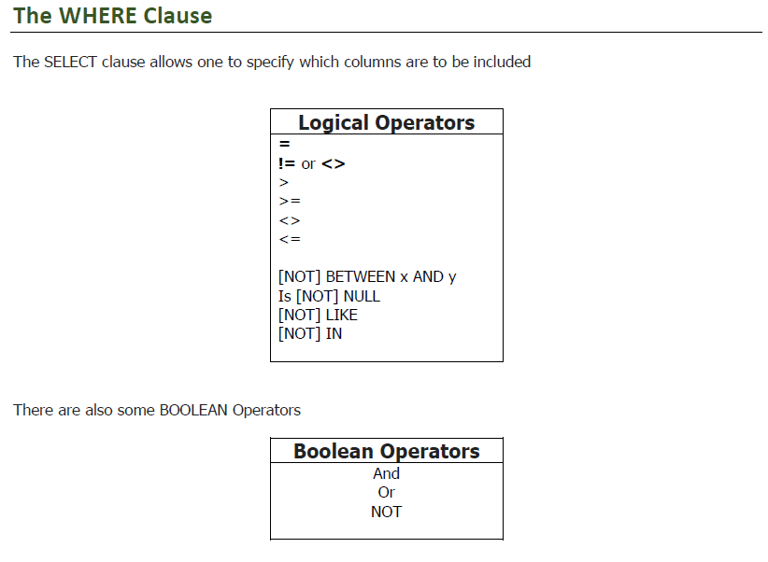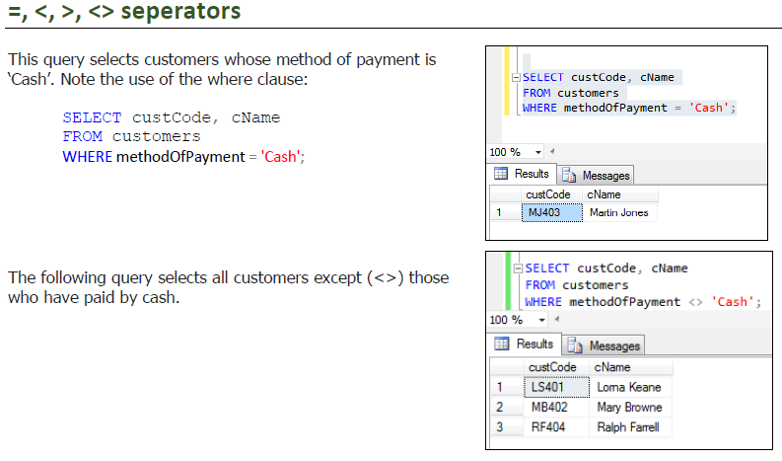

## Order By … Sorting

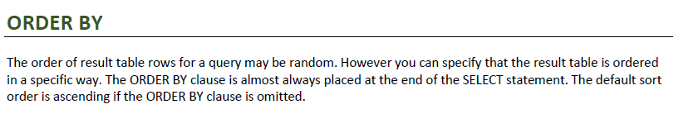

## Like … Searching for a word like … use of WildCards

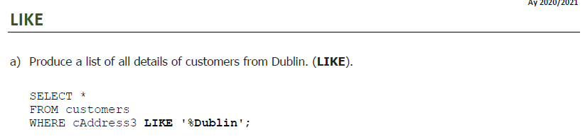

## BETWEEN … Values between a range

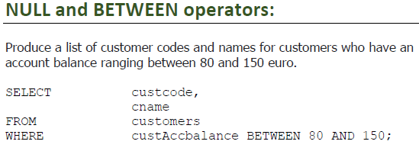

## AND / OR

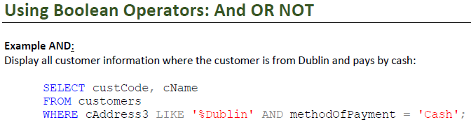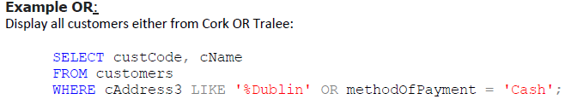

## Calculated Fields

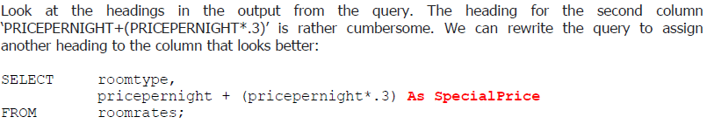

## Aggregate Functions

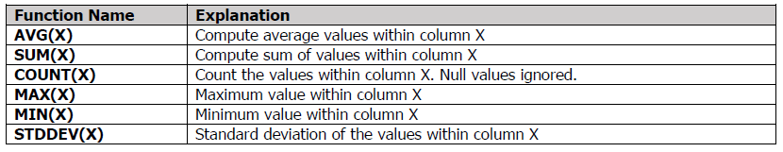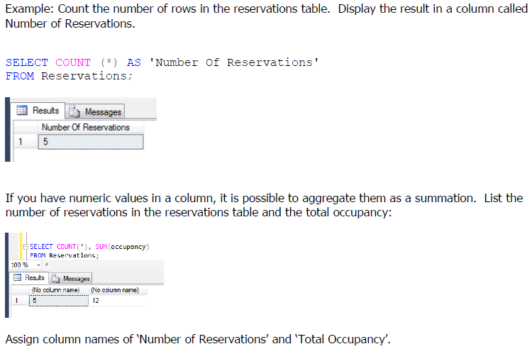

## Use of null

Use personaltrainer;

Select FirstName, LastName from client

where birthdate is null;

# Updating, Transactions and Deleting

## Updating using the Where clause to find record (UPDATE … SET … WHERE)

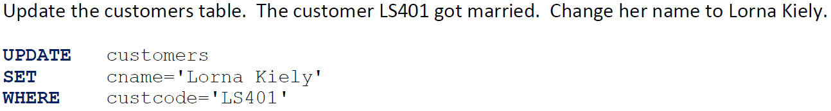

## Transactions … Begin, Commit, Rollback

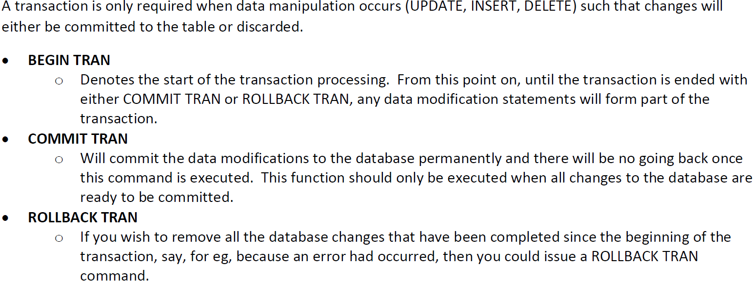

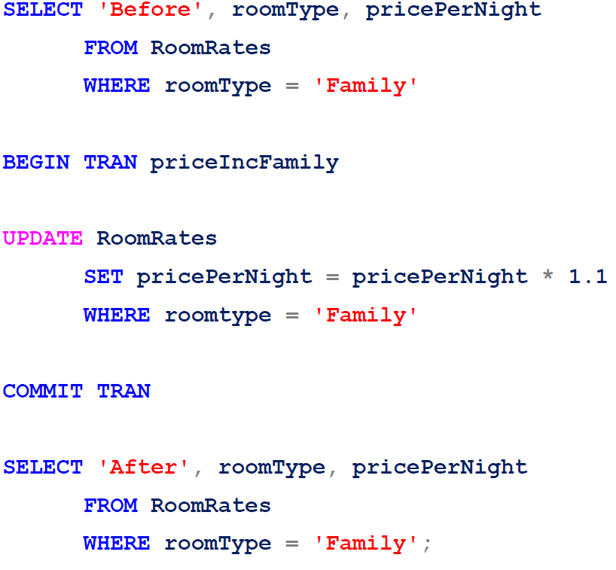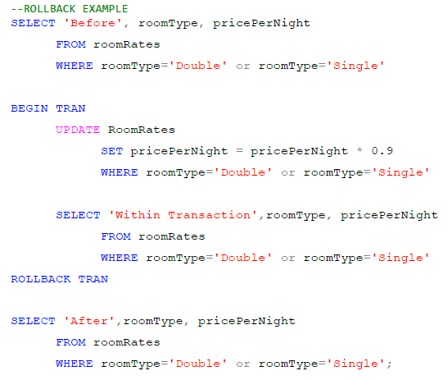

## Delete

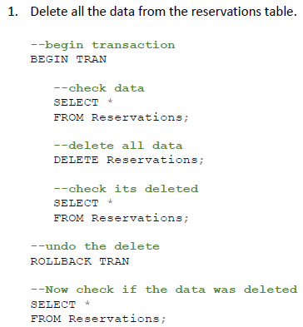

# Aggregates and Subqueries

## Aggregates – Grouping & Having



Typically use AS to have a column heading

Examples:

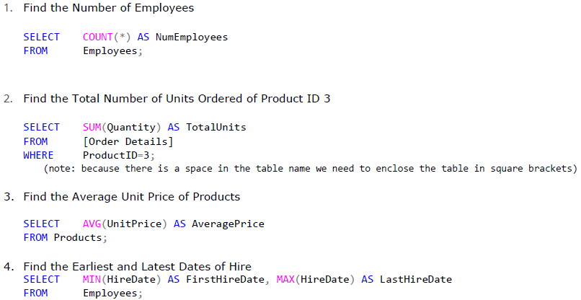

## Group by … Allows for grouping of Aggregate functions

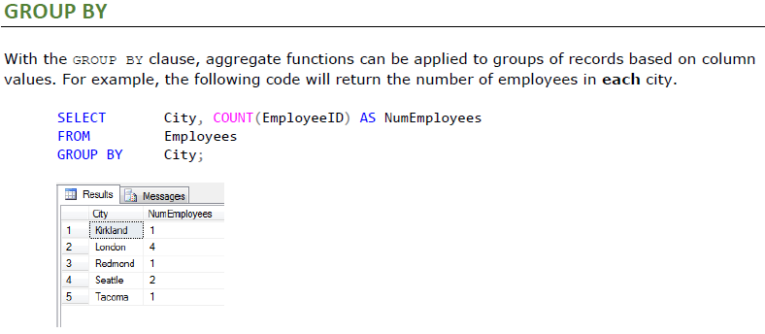

## HAVING … Filtering Grouped data

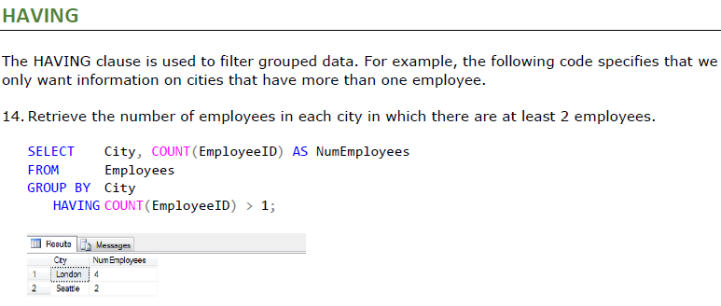

## Grouping / Having Rules

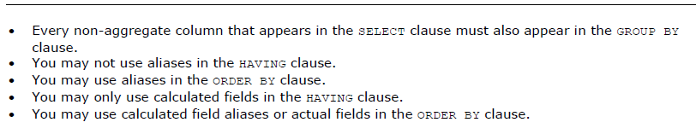

## Subquery

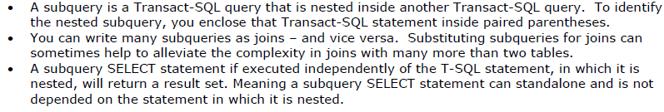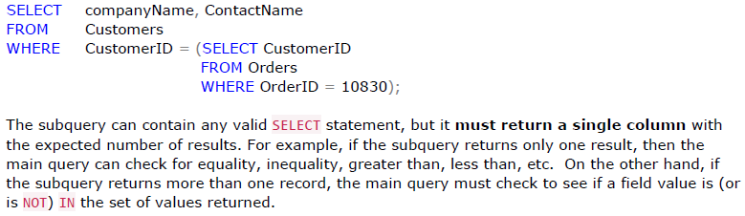

## Joins

Example:

**StockItems** **Suppliers** **Contacts**

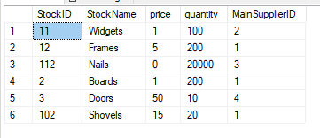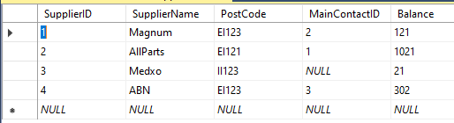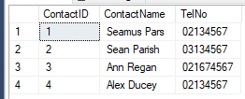

Tables (Connected Fields)

StockItems 🡺 Suppliers (*MainSupplierID/SupplierID*)

Suppliers 🡺 Contacts (*MainContactID / ContactID*)

We use the connected fields as basis of Join

### LEFT JOIN … Show only the results from first table in this case

Select StockItems.StockName, Suppliers.SupplierName, Suppliers.Balance, StockItems.MainSupplierID AS 'ID' from StockItems

LEFT join Suppliers

ON StockItems.MainSupplierID = Suppliers.SupplierID

### WHERE Suppliers.Balance > 100

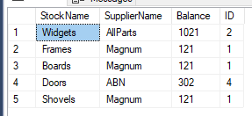

### RIGHT Join … Show results from the second table in this case

Select StockItems.StockName, Suppliers.SupplierName, Suppliers.Balance, StockItems.MainSupplierID AS 'ID' from StockItems

RIGHT join Suppliers

ON StockItems.MainSupplierID = Suppliers.SupplierID

WHERE Suppliers.Balance > 100

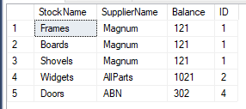

# Links

## Difference between ORDER by and GROUP

<https://learnsql.com/blog/sql-group-by-vs-order-by/>

## 30 Important Sample Queries

<https://learnsql.com/blog/most-important-sql-queries-for-beginners/>

## Sample Exercises

<https://www.w3resource.com/sql-exercises/>

## Generating a ERD from existing MySQL DB

